Autonomous Cars
Why?
Because of convenience and cost effectiveness.
Convenience for the private person that wants to travel from one place to another, because he or she doesn't have to bother with the attention steering demands and the stress it can cause.
Cost effectiveness for the companies that can replace their human drivers with autonomous vehicles that won't get tired and don't require salary, such as cab, truck and bus companies. Even private individuals could let their autonomous car be used as cab by strangers to generate revenue while they don't need it, which makes it even harder for human drivers to compete.
How?
Some car manufacturers are already quite advanced in terms of autonomy such as Tesla with its "Autopilot¹" driver assistance system and Audi with its "Audi AI traffic jam pilot²". What their systems have in common is that they not only rely on one type of sensor, but at least on three different types.
This would be ultrasonic sensors for the area just around the car, cameras on various positions to detect lanes, traffic signs and objects and radar sensors for objects that are 150 to 200³ meters ahead or for objects that are approaching from behind in a range of about 50 meters³, in which case also the lanes left and right of yours are monitored to ensure a safe lane change.
The data of all sensors is being analysed and evaluated by a special processing module that has a very high computing power in order to manage the constant flow of data from all types of sensors and the decision-making what actions should be taken to ensure a safe ride.
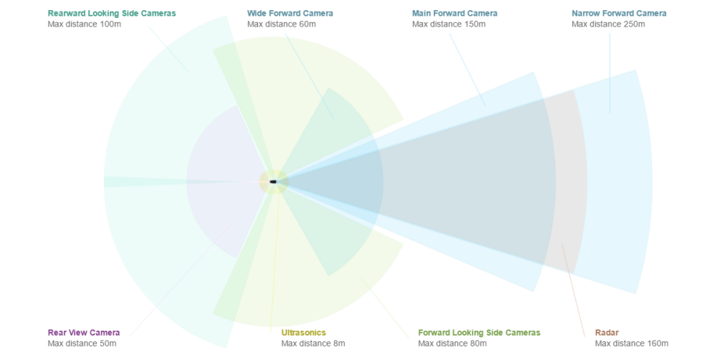
Tesla Sensors and their ranges 2018
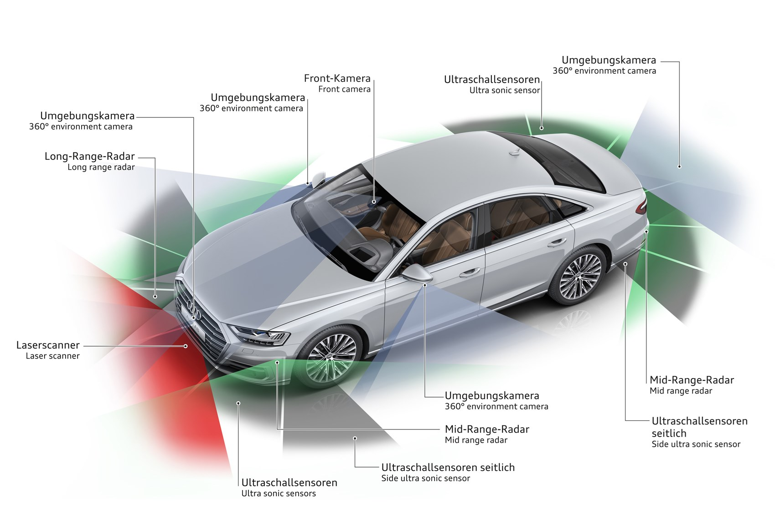
Audi A8 Sensors 2018
As you can see, Audi also utilizes a laser scanner in the front of the car to detect the reflection of the laser light on objects ahead.
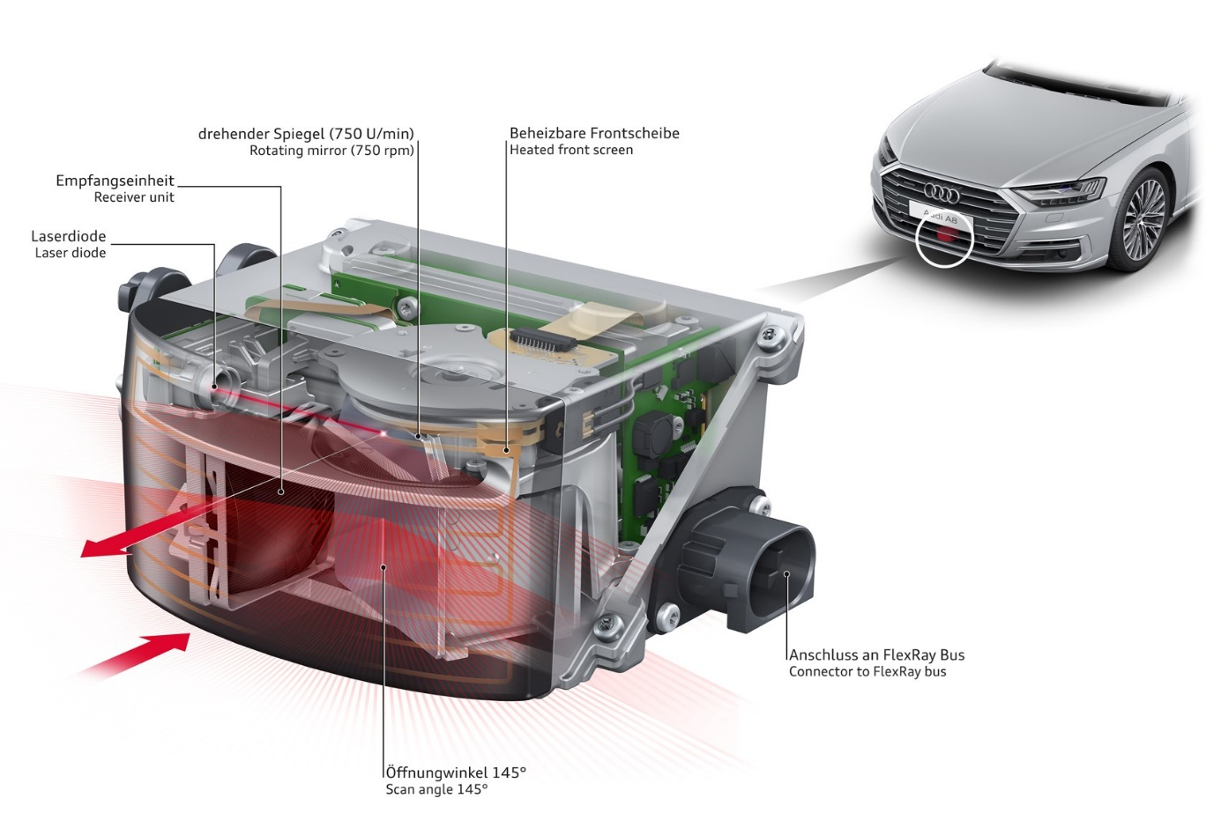
Audi laser scanner 2018
Problems
Legislative regulations delay the approval of test programs and the utilization of the full capabilities of the cars. The most famous might be the (Vienna) Convention on Road Traffic which stated from the 8th November 1968 till 2014 that the driver is always fully in control and responsible for the behaviour of a vehicle in traffic, which excludes all types of driver assistance systems that influence the controlling of a car. However, these systems are now allowed, if they can always be overridden by the driver, due to a rework by the UN in 2014 that took effect in 2016.

There were also a number of incidents involving self-driving cars that lead to the death of the inmates of the car and in one case to the death of a pedestrian.
- Tesla Model S Autopilot⁴ 7th May 2016
- Self-driving Uber Volvo⁵ 18th March 2018
- Tesla Model X Autopilot⁶ 23rd March 2018
As these incidents show us, sensors can be fooled and the technology is still far from being perfect.

Current Situation
Currently the systems are almost exclusively limited to the sole support of the driver. If he or she takes the hands off the wheel for too long, the system will request that the driver puts his or her hands back on the wheel. If he or she does not do so, the system will either turn off or initiate an emergency brake because it supposes that the driver is sleeping or has medical problems.
The only exception is the "Audi AI traffic jam pilot²" it can only operate on motorways with speeds up to 60 km/h during a traffic jam, but Audi takes full responsibility if the car causes an accident and states that the driver can focus his or her attention on other things while the system is active. Audi claims that this system is the first that reaches SAE (J3016) Autonomy Level⁷ 3.
The car manufacturers still have to improve and test the systems excessively for several years and the legislation has to change to legalize fully autonomous systems, but we might already see a great number of autonomous cars (level 3 to 5) on our roads by 2030⁸.

SAE (J3016) Autonomy Levels⁷

SAE Level | Name | Narrative Definition
Human driver monitors the driving environment
0 | No Automation | The full-time performance by the human driver of all aspects of the dynamic driving task, even when "enhanced by warning or intervention systems"
1 | Drive Assistance | The driving mode-specific execution by a driver assistance system of "either steering or acceleration/deceleration" | using information about the driving environment and with the expectation that the human driver performs all remaining aspects of the dynamic driving task
2 | Partial Automation | The driving mode-specific execution by one or more driver assistance systems of both steering and acceleration/deceleration
Automated driving system monitors the driving environment
3 | Conditional Automation | The driving mode-specific performance by an automated driving system of all aspects of the dynamic driving task | with the expectation that the human driver will respond appropriately to a request to intervene
4 | High Automation |  | even if a human driver does not respond appropriately to a request to intervene
5 | Full Automation |  | under all roadway and environmental conditions that can be managed by a human driver

Sources
¹ https://www.tesla.com/autopilot?redirect=no
² https://www.carmagazine.co.uk/car-news/tech/audi-a3-level-3-autonomy-how-did-they-get-it-to-market/
³ https://auto.ricardo.ch/magazin/Portals/ch-autos/Autos/Dokumente/VW%20Preislisten/CC/PL-CC-DE.pdf
⁴ https://www.theguardian.com/technology/2016/jul/01/tesla-driver-killed-autopilot-self-driving-car-harry-potter
⁵ https://www.theguardian.com/technology/2018/mar/22/self-driving-car-uber-death-woman-failure-fatal-crash-arizona
⁶ https://www.theguardian.com/technology/2018/mar/31/tesla-car-crash-autopilot-mountain-view
⁷ https://web.archive.org/web/20170903105244/https://www.sae.org/misc/pdfs/automated_driving.pdf
⁸ http://www.businessinsider.de/nvidia-and-audi-plan-to-bring-a-fully-autonomous-vehicle-to-market-in-2020-2017-1?r=US&IR=T

